How to take Oracle Liunx server backup
Check the disk space
Type : df -h
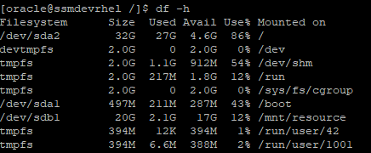
cd /usr/tmp
Create a directory
mkdir Backup
Change permission from root to oracle
sudo chown -R oracle:oinstall resource
Check the created directory
ls –latr

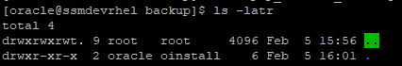

Login in sqlplus ‘/as sysdba’
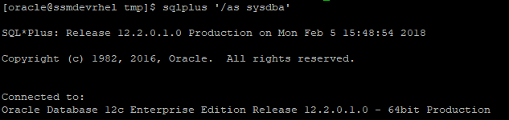
Create a directory in the path
Create directory <naming> as path
create or replace directory EXPDP_BACKUP as '/mnt/resource/Backup';
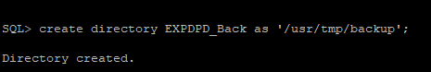
Check the directory created path
select DIRECTORY_NAME,DIRECTORY_PATH from dba_directories;
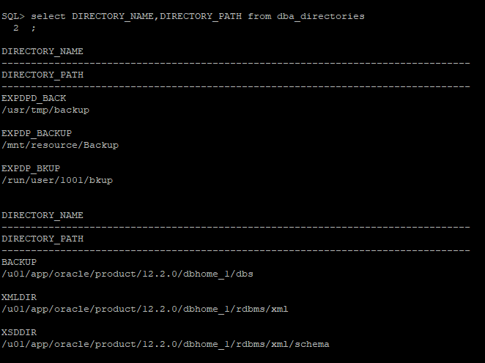
select DIRECTORY_NAME,DIRECTORY_PATH from dba_directories where directory_name='EXPDPD_BACK';
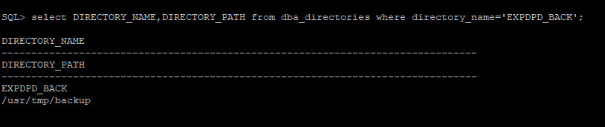
exit
Type : vi <filename.par>
In vi editor
Type shift+i
userid='/ as sysdba'
directory= EXPDP_BACKUP----<directory_name>
dumpfile=expdp_05feb18_1603.dmp ---<file_name.dmp>
logfile=expdp_05feb18_1603.log ---<file_name.log>
schemas= BLACKLIST,BLACKLISTX,COMMON,DDR,MONITORING,REPORT,ROB
COMPRESSION=ALL
FLASHBACK_TIME="TO_TIMESTAMP(TO_CHAR(SYSDATE,'YYYY-MM-DD HH24:MI:SS'),'YYYY-MM-DD HH24:MI:SS')"
.................
userid='/ as sysdba'
directory= EXPDP_BACKUP
dumpfile=expdp_26062018_1017.dmp
logfile=expdp_26062018_1017.log
COMPRESSION=ALL
schemas= BLACKLIST,BLACKLISTX,COMMON,DDR,MONITORING,REPORT,MART,ROB,SYSTEM
FLASHBACK_TIME="TO_TIMESTAMP(TO_CHAR(SYSDATE,'YYYY-MM-DD HH24:MI:SS'),'YYYY-MM-DD HH24:MI:SS')"

Esc Shift : wq
Shift : q!
Check with typing
cat expdp_05feb_1603.par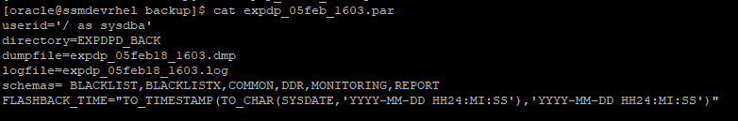
[oracle@ssmdevrhel backup]$ expdp parfile=expdp_05feb_1603.par
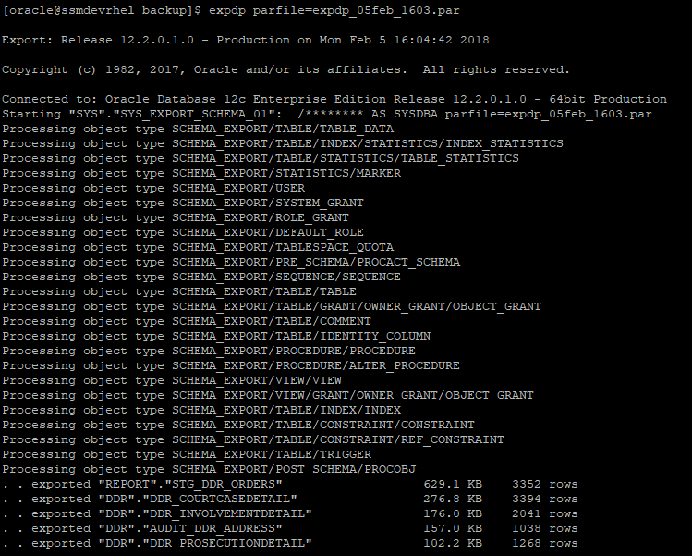
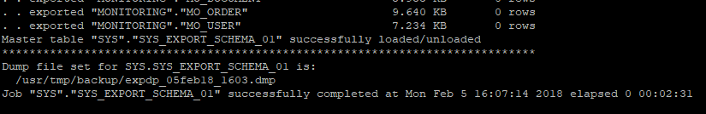

Check the log,dmp,par file
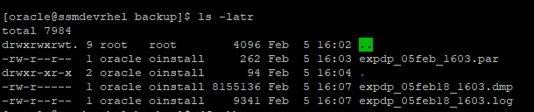
Export the dump where condition
userid='/ as sysdba'
DIRECTORY = DUMPDIR
DUMPFILE = expdp%U.dmp
LOGFILE = expdp_query.log
tables = scdoc.docview
query = "where txday='20231001' and doctyp='51' and substr(actno,1,2) in ('22','62','33','63','77')"

To import the data
userid='/ as sysdba'
directory= IMPDP_BACKUP
dumpfile=expdp_26062018_1017.dmp
logfile=impdp_26062018_1017.log
schemas= BLACKLIST,COMMON,DDR,MONITORING,REPORT,MART,ROB

Using IMPDP TABLE_EXISTS_ACTION

userid='/ as sysdba'
directory= IMPDP_BACKUP
dumpfile=expdp_30072018_0944.dmp
logfile=impdp_30072018_0944.log
TABLE_EXISTS_ACTION=TRUNCATE
Tables= REPORT_BLACKLIST_LISTING
schemas= REPORT

TABLE_EXISTS_ACTION=REPLACE ( Because we are not created any objects, we are just moving data)
TABLE_EXISTS_ACTION=SKIP ( Because the table has to exist, so since it exists, it says skip. Nothing would be loaded).

TABLE_EXISTS_ACTION=APPEND ( Which I think is the default with content=data_only)
TABLE_EXISTS_ACTION=TRUNCATE ( Which would just replace your data. The geometry of the table would have to be the same).

table_exists_action=skip ( This says to ignore the data in the import file and leave the existing table untouched. This is the default and it is not a valid argument if you set content=data_only).

table_exists_action=append ( This says to append the export data onto the existing table, leaving the existing rows and adding the new rows from the dmp file. Of course, the number and types of the data columns must match to use the append option. Just like the append hint, Oracle will not re-user any space on the freelists and the high-water mark for the table will be raised to accommodate the incoming rows).

table_exists_action=truncate ( This says to truncate the existing table rows, leaving the table definition and replacing the rows from the expdp dmp file being imported. To use this option you must not have any referential integrity (constraints) on the target table).

table_exists_action=replace This says to delete the whole table and replace both the table definition and rows from the import dmp file. To use this option you must not have any referential integrity (constraints) on the target table. You use the table_exists_action=replace when the existing table columns do not match the import table columns.

Export only one table
userid='/ as sysdba'
directory= EXPDP_BACKUP
dumpfile=expdp_30072018_1037_test2.dmp
logfile=expdp_30072018_1037_test2.log
tables=REPORT.TEST2
FLASHBACK_TIME="TO_TIMESTAMP(TO_CHAR(SYSDATE,'YYYY-MM-DD HH24:MI:SS'),'YYYY-MM-DD HH24:MI:SS')"

Import one table to different schema
userid='/ as sysdba'
directory= IMPDP_BACKUP
dumpfile=expdp_30072018_1037_test2.dmp
logfile=impdp_30072018_1037_test2.log
tables=report.test2
REMAP_SCHEMA=report:rob

Import one table to different schema in the same table
userid='/ as sysdba'
directory= IMPDP_BACKUP
dumpfile=expdp_30072018_1037_test2.dmp
logfile=impdp_30072018_1531_test2.log
tables=report.test2
REMAP_SCHEMA=report:rob
TABLE_EXISTS_ACTION=append

Import one table without exculde
userid='/ as sysdba'
directory= IMPDP_BACKUP
dumpfile=expdp_30072018_1037_test2.dmp
logfile=impdp_30072018_1531_test2.log
tables=report.test2
REMAP_SCHEMA=report:rob
TABLE_EXISTS_ACTION=replace
exclude= index,constraint,statistics

INCLUDE=TABLE:”IN (‘EMP’, ‘DEPT’)”
EXCLUDE=INDEX:”= ‘PK_EMP'”
REMAP_TABLESPACE=users:REPORTING_DEV

Import the SSMPDC backup SSMUAT server
userid='/ as sysdba'
directory= IMPDP_BACKUP
dumpfile=expdp-db-full-05-Dec-18.dmp
logfile=impdp_05122018_1637.log
REMAP_SCHEMA=SSMPDC:SSMUAT
REMAP_TABLESPACE=SSMPDC:SSMUAT

